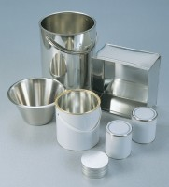 | Sample Container - Plastic 1 litre  Code: 81-3500  Product Group: Moisture Content Tin and Sample Containers

Further Information
**NOT AVAILABLE FOR SALE IN THE USA**

