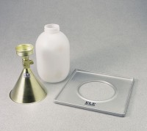 | 6" Field Density Plate  Code: 29-4342  Product Group: Field Density Plates  For use with EI29-4302 Sand Density Cone.

Standards
ASTM D1556, AASHTO T191

