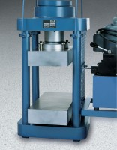 | Platen Set for 8" x 8" x 16" blocks  Code: 37-5522  Product Group: Accu-Tek 250 Series Block Platen Sets, Accu-Tek Touch 250 Series

Further Information
8" x 8" x 16" blocks max.

Specification
Construction | Precision ground and hardened steel; plated for rust and corrosion resistance.
Weight | Net 173 lbs (78 kg)

