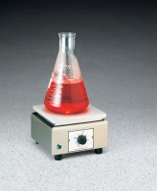 | Hot Plate  Code: 88-0500/02  Product Group: Hot Plates, Bitumen Extraction Test  39 square inch top

Further Information
120vAC, 50/60 Hz, 1ø, 750 Watts.

Specification
Temperature Range | 100Â°C to 700Â°F (38Â°C to 371Â°C).
Top Plate | Cast Aluminum; 6-1/4â x 6-1/4â  (15 9 x 15 9 mm).
Stability | Â±1.1Â°C from 93Â° to 371Â°C
Thermostatic Control | Demand type; with cycle indicator light.
Case | Stainless steel.
Overall Dimensions | 6-5/8â w. x 7-5/8â d. x 4-3/8â h.  (168 x 194 x 111 mm).
Weight | Net 4-1/2 lbs. (2 kg).

