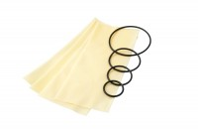 | Rubber Membrane 70mm/2.8 Inch Diameter. Pack of 10.  Code: 25-6441  Product Group: Rubber Membranes, Rubber Membranes, Tri-Flex 2 One-Cell Permeability Test System, Tri-Flex 2 Permeability Test Cell  70 mm / 2.8" mm diameter rubber membrane (Pack Of 10).

Standards
ASTM D2850, ASTM D4767, ASTM D5084, AASHTO T296, AASHTO T297, ASTM D7181

