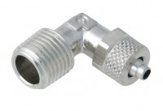 | 6mm Elbow Connector.  Code: 26-1928  Product Group: Volume Change Measurement

