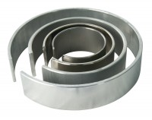 | Membrane Placing Tool 100mm/4 Inch Diameter.  Code: 25-7610  Product Group: Membrane Placing Tools, O-Ring Placing Tools  100Mm/4 Inch Diameter Membrane Placing Tool.

Standards
ASTM D2850, ASTM D4767, ASTM D7181, AASHTO T296, AASHTO T297

