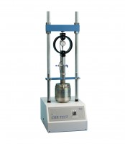 | Cbr-Test 50 Machine 50kN Capacity BS and ASTM Supplied with Stabilising Bar.  Code: 24-9150/01  Product Group: Load frames  • Single speed machine (BS/EN and ASTM)  • Rapid platen adjustment  • Complete with stabilising bar  • Compact, bench-mounting design  • Options for mechanical or electronic measurement  Designed for performing laboratory CBR tests to BS 1377, EN13286-47 and ASTM D1883, this bench mounting machine comprises a twin column frame incorporating a motorised drive system. Rapid adjustment of the platen is provided, which enables daylight to be taken up quickly and also close control of application of a seating load.

Standards
BS 1377, BS 1924, EN 13286-47, ASTM D1883, AASHTO T193

Specification
Dimensions (l x w x h) | 550 x 400 x 1220 mm
Max vertical clearance | 800 mm
Horizontal clearance | 255 mm
Platen diameter | 133 mm
Platen travel | 105 mm
Weight kg | 80

