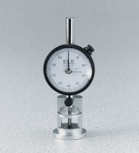 | Asphalt Flow Indicator with Brake - Metric  Code: 45-6894  Product Group: Marshall Stability Breaking Head, Asphalt Flow Indicator with Brake, Marshall Stability Tester

Standards
ASTM D6927, AASHTO T245

Specification
Holder | Cast aluminum.
Dial Indicator | Special type with brake.
Range | 25 .4 mm x 0.254 mm  divisions.
Weight | Net 12 oz. (340 g).

