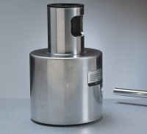 | Testing Anvil  Code: 35-1530  Product Group: Testing Anvil, Surface Hardness, Concrete Test Hammer

Standards
ASTM C805

