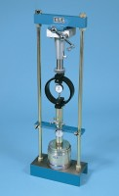 | 45kN (10000Lb) Capacity Mechanical Jack.  Code: 24-9290  Product Group: Conversion of In-situ to Laboratory CBR, In-situ CBR  The body is corrosion protected and houses an enclosed worm and wheel gear. The gear ratio has been carefully selected to provide a handwheel speed that can be comfortably maintained, particularly with soils of high CBR value. A quick-release device in the screwjack allows the plunger to be rapidly adjusted prior to the test.

