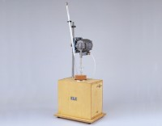 | Heat of Hydration Apparatus  Code: 38-4600/01  Product Group: Heat of Hydration Cement  For 220 - 240 V AC, 50 Hz, 1 ph.

Standards
BS 4550

Further Information
**NOT AVAILABLE FOR SALE IN THE USA**

Spares/Consumables
 | Beckman Thermometer and Reader Glass  Code: 38-4600/12
Dewar Flask
Code: 38-4600/10
Glass Paddle for Stirrer
Code: 38-4600/13

