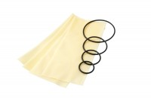 | Membrane Sealing Ring 100mm Diameter. Pack of 10.  Code: 25-7631  Product Group: Membrane Sealing Rings, Sealing Rings, Tri-Flex 2 Permeability Test Cell  100 mm diameter membrane sealing ring (Pack Of 10).

Standards
ASTM D2850, ASTM D4767, ASTM D5084, AASHTO T296, AASHTO T297

