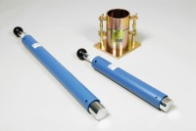 | Straight Edge 300mm.  Code: 24-9010  Product Group: Straightedge, BS/EN compaction test 4.5kg, Proctor compaction  300 mm

Standards
BS 1377-4, BS 1924-2, EN 1997-2, ASTM D698, ASTM D1557, AASHTO T99

Specification
Construction | Flat ground tool steel; beveled edge.
Dimensions | 12 â l. x 1-1/4â w. x 1/8â thick (305 x 32 x 3 mm).
Weight | Net 9 oz. (255 g).

