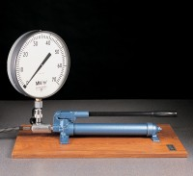 | Hand Operated Pressure System. Complete with Pressure Gauge and Flexible Hose.  Code: 70-5000  Product Group: Hydraulic Constant Pressure Systems

Specification
Pump | Single piston
Maximum pressure | 70 mPa
Gauge | 250 mm diameter scale marked 0-70 MN/m²
Weight | 14.8 kg

Spares/Consumables
 | Spare Jacket Nx Size.  Code: 70-1712

