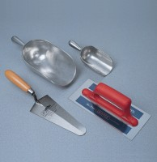 | Scoop - 250 mm long  Code: 81-0222  Product Group: Scoops and Shovels

Further Information
**NOT AVAILABLE FOR SALE IN THE USA**

