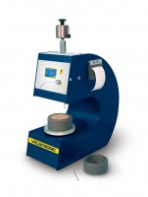 | Automatic Vicat Apparatus  Code: 38-2015/01  Product Group: Automatic Vicat  Complete with EN and ASTM Initial and Final needles, Consistency Plunger, Windows(R) software and RS232 cable, 1 x EN and ASTM Mould and Glass Plate. Suitable for continuous use in saturated humidity, at a controlled temperature of 20°C ± 1°C.

Standards
ASTM C187, ASTM C191

Further Information
**NOT AVAILABLE FOR SALE IN THE USA**
For 220 - 240 V AC, 50 - 60 Hz, 1 ph.

Spares/Consumables
 | ASTM Initial and Final Set Needle  Code: 38-2023
Consistency Plunger
Code: 38-2015/16
EN Initial and Final Set Needle
Code: 38-2021

