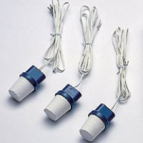 | Soil Moisture Block 0.9 m Lead  Code: 514-128  Product Group: Soil Moisture  0.9 Meter Long Lead

