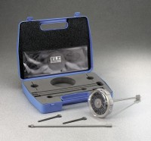 | 33 mm Diameter Vane and Carry Case  Code: 26-3346/10  Product Group: Hand Vane Tester  For readings from 0 - 28 kPa (585 lbs./sq. ft.)

Standards
ASTM D2573, ASTM D4648

