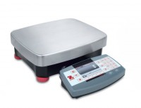 | Ohaus Electronic Balance - 35,000 g Capacity  Code: 88-1104/02  Product Group: Ohaus Series Electronic Balances

Further Information
100-240V, 50/60 Hz.

Specification
Maximum Capacity | 35000 g
Readability | 0.5 g
Internal Calibration | NO
Pan Size (in/cm) | 11.0 x 14.9 in / 28.0 x 37.7 cm
Dimensions w x h x d (in/cm) | 14.9 x 18.4 x 5.0  in / 37 x 46.7  x 12.8 cm
Shipping Wt. (lb/kg) | 24 lb / 10.6  kg

