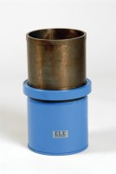 | 150mm Dia Cylinder Mould 150mm Long.  Code: 34-5230  Product Group: Cylinder Moulds  150 mm diameter x 150 mm long, complete with base plate.

Further Information
**NOT AVAILABLE FOR SALE IN THE USA**

