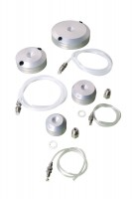 | Pressure Pad 70mm Diameter.  Code: 25-6430  Product Group: Specimen Caps, Pressure Pads  70 mm / 2.8" diameter pressure pad. The pad shall have two empty ports and will come complete with two blanking plugs, plastic tubing and connector. Suitable For both drained and undrained tests.

Standards
ASTM D2850, ASTM D4767, ASTM D5084, AASHTO T296, AASHTO T297, ASTM D7181

