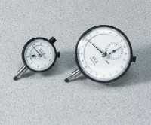 | Mechanical Dial Indicator - 0.3" Range  Code: 88-4040  Product Group: Mechanical Dial Indicators

Specification
Range | 0.3"
Divisions | 0.0001"
Movement | Clockwise
Face Diameter | 2-1/4"
Contact Point | Immediate response, up or down; tip movement magnified to indicator hand with minimal friction; 3/16â (5 mm) radius x 1/4â (6 mm) l.
Dials | With continuous graduations and revolution counters.
Measure Movement | Measure movement towards dial case; pointer at zero with stem extended.
Weight | Net 12 oz. (34 0 g).

