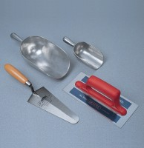 | Aluminium Scoop Large  Code: 81-0220  Product Group: Slump Test, Scoops and Shovels

Further Information
**Not available for sale in the USA**

