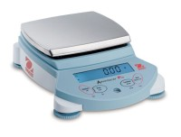 | Ohaus Electronic Balance - 8,100 g Capacity  Code: 88-1084/02  Product Group: Ohaus Series Electronic Balances  Includes weigh-below hook.

Further Information
100-240V, 50/60 Hz.

Specification
Maximum Capacity | 8100 g
Readability | 0.1 g
Repeatability (Std. Dev.) | 0.1 g
Linearity | +/-0.2g
Internal Calibration | NO
Pan Size (in/cm) | 5.8 x 6.3 /  14 .9 x 16.2
Dimensions w x h x d (in/cm) | 7.5 x 2.8 x 10 /  19.3 x 7.2  x 25 .4
Shipping Wt. (lb/kg) | 9.5 / 4.3

