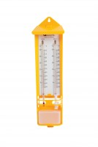 | Wet & Dry Bulb Hygrometer  Code: 506-106  Product Group: Humidity measurement  • Easy to read.  • Use outdoors in a screen.  The wet and dry bulb hygrometer is designed for general use and consists of two undivided thermometers mounted on a printed plastic scale. Between the thermometers is a unique slide pointer which allows relative humidity to be easily read. The scale is housed in a plastic case which also holds a reservoir with anti-frost device

Further Information
Easy to read pattern, range -10 to +50°C Easy to read pattern, range -10 to +50°C Easy to read pattern, range -10 to +50°C Easy to read pattern, range -10 to +50°C Easy to read pattern, range -10 to +50°C Easy to read pattern, range -10 to +50°C Easy to read pattern, range -10 to +50°C Easy to read pattern, range -10 to +50°C Easy to read pattern, range -10 to +50°C

