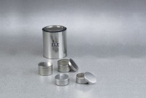 | Aluminium Moisture Cans - 3-1/2" Diameter  Code: 88-7008  Product Group: Aluminium Moisture Boxes  3-1/2" diam. x 2" h. (90 x 51 mm). Carton of 12.

Specification
Construction | Heavy-gauge aluminum.
Lid | Fits onto bottom as well as top of box.

