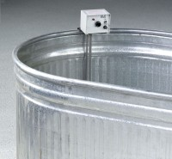 | Concrete Curing Tank  Code: 34-6763  Product Group: Concrete Curing Tanks  182 Gal. capacity

Specification
Construction | 20-gage sides with 20-gage bottom with zinc coating; rolled top for added stiffness; drain plug.
Dimensions | 72" l. x 30" w. x 24" d. (1,829 x 762 x 610 mm).
Weights. | Net 90 lbs. (41 kg).

