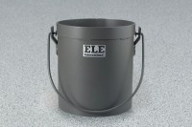 | Yield Buckets 1/2 cu. Ft. Capacity  Code: 34-2862  Product Group: Yield Buckets, Yield Buckets  1/2 cu. Ft. Capacity

Standards
ASTM C138, AASHTO T121

Specification
Construction | Heavy-duty steel; welded connecting edges; water tight.
Handle | Bail-type with welded lugs.
Dimensions | 10â (254 mm) i.d. x 11 â  (279 mm) inside h.
Weights | Net 20 lbs. (9.0 kg).

