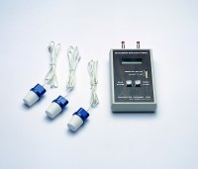 | Soil Moisture Meter.  Code: 514-126  Product Group: Soil Moisture  Battery operated, 9 V battery supplied.

