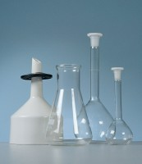 | Conical Flask (Erlenmeyer) - 250 ml  Code: 82-1140  Product Group: Funnels and Flasks  Borosilicate glass, wide mouth graduated, 50 ml sub-divisions

Further Information
**NOT AVAILABLE FOR SALE IN THE USA**

