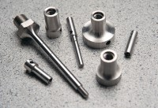 | Set of Needle Points 1 1/2 1/4 1/10 1/20 1/40 Inch Sq.  Code: 34-0810  Product Group: Setting Time by Penetration Resistance  Stainless steel, 1, 1/2, 1/4, /10, 1/20 and 1/40 in2 area (645, 323, 161, 65, 32 and 16 mm2) with stainless steel adaptor for the smaller needles.

Further Information
**NOT AVAILABLE FOR SALE IN THE USA**

