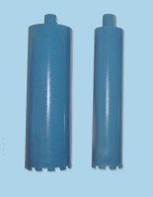 | Core Barrel 100 mm  Code: 47-5565  Product Group: Core Barrels

Standards
EN 12697-32, EN 13280-4, BS 598-104

Further Information
**NOT AVAILABLE FOR SALE IN THE USA**

