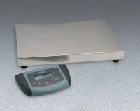 | ES Series Low Profile Bench Scale 110 lb Capacity  Code: 88-1424/02  Product Group: ES Series Low Profile Bench Scales  110 lb./50 kg. capacity. 120vAC, 50/60 Hz

Further Information
120V, 50/60 Hz.

Specification
Capacity | 11 0 lb. x 0.05 lb. or 50 kg x 0.02 kg.
Platform Size | 12 .2â x 10.8â (31 x 27 cm).
Power | 9 vDC/AC adapter (included) or six âAAâ  batteries (not included).
Weights | Net 6.6 lbs. (3 kg).

