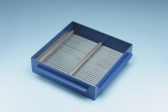 | Grid Sieve 40mm Slot Width for EN Aggregate Flakiness Test.  Code: 42-0326  Product Group: Grid Sieves  40mm

Standards
EN 933-3

Further Information
**NOT AVAILABLE FOR SALE IN THE USA**
Passing Size - 80 mm Retained Size - 63 mm

