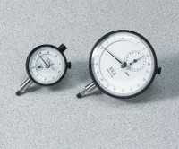 | Dial Indicator - 1.0" Range  Code: 88-4100  Product Group: Digital Tritest 50 Load Frame, Hveem Stabilometer, CBR Loading Press, Hand-Operated, Tripod Attachment, CBR-Test 50 Machine, Mechanical Dial Indicators, Direct/Residual Shear Apparatus  1.0" x 0.001" divisions.

Specification
Range | 1.0"
Divisions | 0.001"
Movement | Clockwise
Face Diameter | 2-1/4"
Contact Point | Immediate response, up or down; tip movement magnified to indicator hand with minimal friction; 3/16” (5 mm) radius x 1/4” (6 mm) l.
Dials | With continuous graduations and revolution counters.
Measure Movement | Measure movement towards dial case; pointer at zero with stem extended.
Weight | Net 12 oz. (34 0 g).

