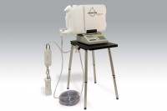 | Aardvark Permeameter Kit  Code: 514-400  Product Group: Permeability

