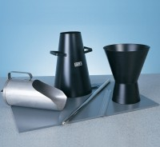 | Base Plate for Slump Test.  Code: 34-0160  Product Group: Slump Test

Further Information
**NOT AVAILABLE FOR SALE IN THE USA**

