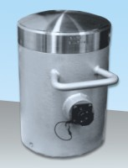 | 2000 kN Capacity Calibration Load Cell with Hand-Held Readout  Code: 37-8315  Product Group: Calibration Devices  Supplied with rechargeable batteries and universal charger.

Further Information
**Not available for sale in the USA**
110 - 240 V, AC 50 - 60 Hz, 1 ph.

