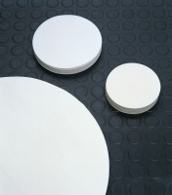 | Filter Paper - Medium  Code: 82-7901  Product Group: Filter Papers (Box of 100)  No. 74 x 150 mm diameter.

Further Information
**NOT AVAILABLE FOR SALE IN THE USA**

