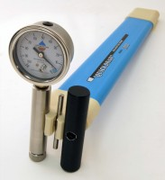 | Quickdraw soil moisture probe 460 mm  Code: 514-012  Product Group: Tensiometers  460 mm long

Further Information
Supplied with coring tool and carrying case.

Spares/Consumables
 | Replacement Dial Gauge.  Code: 514-010/12

