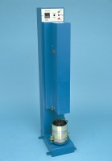 | Automatic Soils Compactor ASTM 220-240V 60Hz 1Ph.  Code: 24-9095/06  Product Group: Automatic Compactors

Standards
ASTM D558, ASTM D559, ASTM D560, ASTM D698, ASTM D1557, AASHTO T99, AASHTO T134, AASHTO T135, AASHTO T136, AASHTO T180

Further Information
For 110 - 120 V AC, 60 Hz, 1ph

