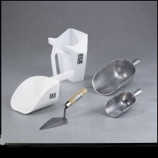 | Plastic Flat Bottom Scoop - 1 qt. Capacity  Code: 88-7310  Product Group: Plastic Flat Bottom Scoops  1 qt. (0.946 liter) capacity.

Specification
Bowl Dimensions | 6-3/4â x 5-1/4â x 3-1/4â (171 x 133 x 83 mm).

