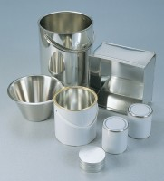 | Sample Container - Tinned Steel 0.5 litres  Code: 81-3000  Product Group: Moisture Content Tin and Sample Containers

Further Information
**NOT AVAILABLE FOR SALE IN THE USA**

