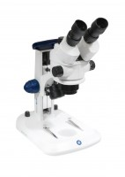 | Binocular Stereo Zoom Microscope  Code: 550-025/01  Product Group: General laboratory instrumentation  • 4 objective nosepiece.  • High quality optics.  • Mechanical stage.  This binocular miroscope has a sound, ergonomic design and is manufactured to a high standard. The excellent optical performance makes the instrument suitbale for both laboratory and teaching purposes. The built-in illumination with daylight filter provides an excellent light source for a wide range of applications.

Further Information
For 220-240 V, 50 Hz, 1 ph.

Spares/Consumables
 | Bulb (Bottom Illumination) 12V/20W  Code: 550-025/12
Bulb (Top Illumination) 12V/10W
Code: 550-025/10

