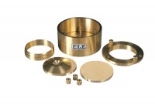 | Calibration Disc 2.5 Inch Cell  Code: 25-0485  Product Group: ASTM/AASHTO consolidation cells and accessories, Fixed Ring Consolidation

Standards
ASTM D2435, ASTM D4546, AASHTO T216

