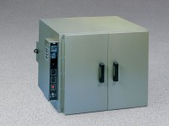 | Bench Oven - Hydraulic Thermostat - 7 cu. ft. capacity - 115vAC  Code: 88-0130/02  Product Group: Bench Ovens  115vAC, 50/60 Hz, 1ø.

Specification
Capacity | 7 cu.ft. (198 liters).
Chamber Size | 25 .5â w. x 24 â d. x 20â h. (648 x 610 x 508 mm).
Temperature Range | 51 .7Â°C to 225 Â°C  (125 Â°F. to 43 7Â°F).
Thermostat | Hydraulic.
Shelves | Two included.
Overall Dimensions | 33 â w. x 36.75â d. x 24 â h. (838 x 933 x 610 mm).
Weight | 170 lbs. (77.6 kg).

