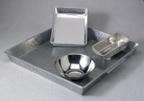 | Mixing Pan - Rectangular Aluminium  Code: 88-7110  Product Group: Mixing Pans and Bowls  Aluminum; 9” x 13” x 2” (229 x 330 x 51 mm).

