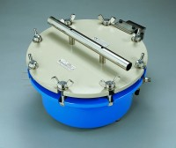 | 15-Bar Pressure Plate Extractor.  Code: 532-120  Product Group: Pressure plate extractors  Supplied without ceramic plate cells

