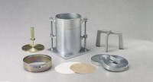 | Slotted Surcharge Weight 10 lb  Code: 24-9246  Product Group: Surcharge Weights  8-1/2” o.d. (216 mm).

Specification
Construction | Machined steel.
Finish | Plated.

